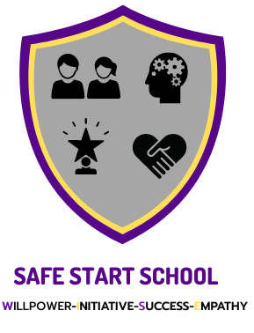

Two-way Radio Policy

Policy Created: September 2023
Reviewed by: Grace Speakman
Review Date: September 2024

Radio communications enable school staff to communicate using devices such as walkie-talkies.
Due to the nature of how schools operate, schools have an unusually high number of team members who work alone. And as such every employer is ultimately responsible for the safety of the members of their team. Two way radios (or walkie talkies) allows the teacher to effectively manage the risk and call for assistance without delay as soon as an incident starts.
Walkie talkies can improve the safety and security of the whole site, by allowing staff to summon help and inform colleagues of any emergency or situation quickly, wherever they may be located on the premises.
- Incidents
- Manual Handling
- Medical Incident
- Evacuation Procedure
- School Trips and event management
- General communication between staff

Instant communications are absolutely essential in the event of an incident. Whether that be a medical incident or something more serious that requires immediate evacuation, two-way radios (or walkie talkies) almost certainly provide the correct solution.
Unlike a mobile phone, where there is a delay in the ring/answering period (up to a minute), two-way radios (or walkie talkies) make communication instant. That results in no time delay incidents which are time critical such as fire evacuation.
Two-way radios are recognised as the preferred method of instant communication by almost all health & safety recognised bodies including the Health & Safety Executive itself.
Due to the introduction in the last few years of the licence free radio system, known as ‘PMR 446’ , many schools have chosen these short range handheld radios. However, this method is not private and can be accessed by other radio users within range. Therefore, school staff are trained in correct usage of radio communications, not only to comply with data protection requirements, but also potential safeguarding danger issues.
Training includes:
- ensuring students do not access radios
- not using students first or last names
- charging radios every evening

