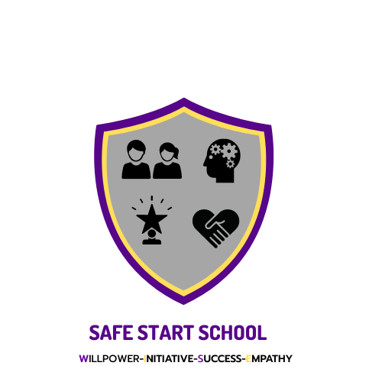
Reviewed: Nov 2023
By: Grace Speakman
Next Review: Nov 2024
Pupil Mental Health & Wellbeing Policy

At Safestart School, we are committed to supporting the mental health and wellbeing of all our pupils. Our culture is supportive, caring, and respectful. We encourage pupils to be open and we want each pupil to have their voice heard. At our school, we know that everyone experiences different life challenges, and that each of us may need help to cope with them sometimes. We understand that anyone and everyone may need additional emotional support. At our school, positive mental health is everybody’s responsibility. We all have a role to play.
POLICY SCOPE
This policy is a guide to all staff, including teachers, governors, and non-teaching staff. It outlines our approach to promoting pupil mental health and wellbeing.
At Safestart, we will always:
Help children to understand and regulate their emotions
Ensure our pupils feel comfortable sharing any concerns and worries
Help children to form and maintain relationships
Encourage children to be confident and help to promote their self-esteem
Help children to develop resilience and ways of coping with setbacks
Develop a good mind-set.

We will always promote a healthy environment by:
Promoting positive mental health and emotional wellbeing
Celebrating both academic and non-academic achievements.
Promoting our school values and encouraging a sense of belonging and community
Providing opportunities to develop a sense of worth and to reflect
Promoting our pupils’ voices and giving them the opportunity to participate in decision making
Celebrating each pupil for who they are and making every pupil feel valued and respected
Adopting a whole school approach to mental health and providing support where needed it
Raising awareness amongst staff, parents and pupils about mental health issues and their signs and symptoms
Enabling staff to respond to early warning signs of mental-ill health in pupils
Signposting pupils and their families to internal and external support
KEY STAFF MEMBERS
All staff members have a responsibility to promote the mental health of pupils and each other. However, certain staff members have a specific role in the process. These are:
Our Designated Safeguarding Officers: Jodie Taylor & Emily Pilling
IDENTIFYING NEEDS AND WARNING SIGNS
All of our staff will be trained in how to recognise warning signs of common mental health problems. This means that they will be able to offer help and support to students who need it, when they need it. These warning signs will always be taken seriously and staff who notice any of these signs will communicate their concerns with the Designated Safeguarding Officer as appropriate.
Staff will be able to identify a range of behaviour and physical changes, including:
• Physical signs of harm.
• Changes in eating and sleeping habits.
• Increased isolation from friends and family and becoming socially withdrawn.
• Changes in mood.
• Talking and/or joking about self-harm and/or suicide.
• Drug and alcohol abuse.
• Feelings of failure, uselessness, and loss of hope.
• Secretive behaviour.
• Clothing unsuitable for the time of year, e.g. a large winter coat in summer.
• Negative behaviour patterns, e.g. disruption.

Staff will also be able to identify a range of issues, including:
• Attendance and absenteeism.
• Punctuality and lateness.
• Changes in educational attainment and attitude towards education.
• Family and relationship problems. Finally, staff will be well placed to identify any additional needs arising from difficulties that may impact a child’s mental health and wellbeing, such as bereavement, health difficulties, and family circumstances.
MANAGING DISCLOSURE
If a pupil discloses concerns about themselves or a friend, to any member of staff, then all staff will respond in a calm, supportive, and non-judgemental manner. Staff will not ask leading questionings but repeat the pupil’s words for clarification. All disclosures will be recorded confidentially on our electronic system (CPOMS) and will only be shared with the appropriate authorities if it’s necessary to keep the child safe, in line with our Safeguarding Policy. The disclosure record will contain:
• The date of the disclosure.
• The name of the staff member to whom the disclosure was made.
• The nature of the disclosure and the main points from the conversation.
• Agreed action.
WHOLE SCHOOL APPROACH
We take a whole school approach towards the mental health of our students. This means working with parents and carers and with other agencies and partners, where necessary.
WORKING WITH PARENTS AND CARERS We aim to support parents as much as possible. This means keeping them informed about their child and offering our support at all times. To support parents we will:
Listen to their concerns regarding their child
Highlight sources of information and support about mental health and emotional wellbeing that we have in our school.
Share and allow parents to access further support.
Ensure that parents are aware of who to talk to if they have any concerns about their child.
Give parents guidance about how they can support their child’s/children’s positive mental health.
Ensure this policy is easily accessible to parents.
TRAINING
All staff will receive regular training in child mental health so that they can recognise and respond to mental health issues. This will form part of their regular safeguarding training and is a requirement to keep children safe. Training records will be held in. We will post all relevant information, and additional information, on our school website so staff can learn more about child mental health. We will consider additional training opportunities for staff and we will support additional CPD throughout the year where it becomes appropriate due to developing situations with pupils.

