Lone Working Policy
Policy Written By; Rachel Duffy
Ratified by ; Mrs Rachel Pilling Proprietor
Review Date 13/10/2024

Buddy Team Contact List
Name | Mobile Number
Grace Speakman | 07427476543
Emily Pilling | 07427476651
Emma Byrne | 07445070810
Cheryl McDonald | 07427476613

Outreach Locations Whereabouts Form
Time of Visit:
Who are you visiting:
Who is your buddy:
Expected end time and where:
Time and method of check in with buddy

Service User Outreach Visit Process
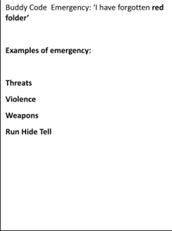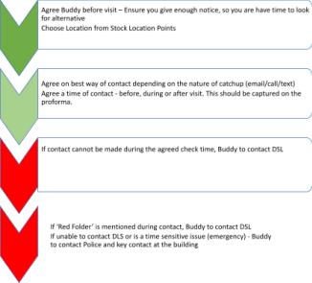

1.Introduction
Lone workers are people who work by themselves, without interaction with other workers or without close or direct supervision.
Therefore a lone worker may be the only person working on the site, or may be working remotely from other people who are working on the site at the same time.
Examples of lone workers include employees who:
Work outside normal working hours, for example cleaners, site staff (Site Manager, Caretaker, School Keeper) or staff/managers working early or late. Work separately from others, for example, in offices, interview rooms, storage areas, boiler rooms, workshop or laboratory preparation rooms.
Work totally alone in a building, for example cleaners, site staff (Site Manager, Caretaker, School Keeper) or staff/managers working in an annex, portacabin, separate building.
Work during holiday periods.
Work away from their base, for example home school support visits.
Work at or from home.

1. Risk Assessment
There are no specific prohibitions regarding working alone, but employers are required under the Health & Safety at Work etc. Act 1974 (2) to ensure the health, safety and welfare of their employees whilst at work.
In addition, under the Management of Health & Safety at Work Regulations 1999 (3) managers must make a suitable and sufficient assessment of the risks to the health and safety of employees to which they are exposed while at work.
The decision as to whether or not employees should work alone must therefore be based on risk assessment, along with any specific restrictions and the provision of suitable control measures. The risk assessment should also help managers decide on the appropriate level of supervision and training (4). Organising safe working arrangements for lone workers is no different from organising safe working arrangements for other staff.
However, lone workers may face particular problems, for example:
Can the risks of the job be adequately controlled by one person?

Lone workers should not be put at greater risk than other employees, therefore additional measures may need to be taken in order to achieve this. Precautions should take account, not only of normal work, but also foreseeable emergencies such as fire, illness, accidents and equipment failure.
Managers need to ensure that the medical condition would not expose the lone worker to an unacceptable level of risk, which cannot be reduced using the available or additional control measures. In some cases the medical condition may make it unacceptable for the person to work alone.
Consideration should be given to both normal work, and foreseeable emergencies that may impose additional physical and mental burdens on the lone worker.
3.How will the person be supervised?
The extent and level of the supervision is a management decision and should be based on the findings of the risk assessment, the risks involved and the competence of the lone worker. It should not be left to the lone worker to decide whether they require supervision or assistance.
Staff new to the job, undergoing training, dealing with new situations, or doing a job with special risks may need closer supervision, or to be accompanied to begin with. Procedures will need to be established to monitor lone workers and ensure their health and safety.
These may include:
o Periodic visits to lone workers.
o Regular contact with the lone worker using telephone, mobile phone, radios, or e-mail.
o Checks to ensure the lone worker has returned to base, or home once the task has been completed, or after an agreed time period. During the Lone working designated task the lone worker will have an allocated “Buddy” a member of SLT who will contact the staff member every hour. The code word during an emergency will be “ I have forgotten the Red folder”
A senior member of staff will support at the required location.
In an emergency the staff member must contact the emergency services if at immediate risk.
All staff who work must have completed the schools mandatory training on Safeguarding .

4. How we will monitor safety issues.
Lone workers must report incidents such as accidents and near misses, including all incidents where they feel threatened, in the School Software CPOMS . This includes incidents of verbal abuse.
During supervision, managers will ask people working on their own whether there are any safety concerns that aren't being addressed.
Lone workers are encouraged to seek help and advice if any safety concerns arise.
Lone workers should in the first instance consult with their designated line manager then the Headteacher with further concerns.

5. Withdrawing from lone working activity
Senior Leaders must ensure that the lone worker is supported if they decide that they need to terminate the work they are carrying out to protect their (or others’) safety.
For example, when working at height and wind speeds increase during the course of the work or visiting a person who uses a service who becomes verbally aggressive and threatening.
Staff who wish to have lone working reviewed must ;
- Request a meeting with Line Manager
- Discuss job roles available with HeadTeacher & Proprietor
- Review their job description with a 10 day consultation period supported by the schools governing body.
For example, when working at height and wind speeds increase during the course of the work or visiting a person who uses a service who becomes verbally aggressive and threatening.

