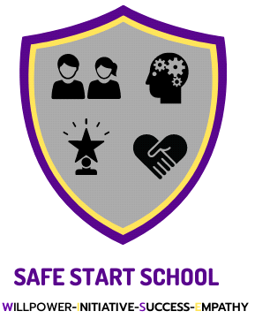

DRESS CODE POLICY
SAFESTART

The Teaching profession is a formal and professional vocation that encompasses both teaching and support staff. A staff dress code should reflect expected professional standards as it is important that all school staff project a professional image to students, parents and external professionals and agencies.
Staff are individually responsible for their general presentation, appearance and personal hygiene and should consider how this may be perceived by others. This means that all staff should wear clothing which:
- Is appropriate to their role.
- Is not likely to be viewed as offensive, revealing or sexually provocative.
- Is absent of any political or otherwise contentious slogans.
- Is not considered to be discriminatory and is culturally sensitive.
- Does not place themselves or others at risk and complies with any health and safety requirements.
ACCEPTABLE CLOTHING
- Blouses/shirts (long or short sleeve)
- Smart plain T-shirts/polo shirts
- Smart casual trousers
- Smart, tailored shorts
- Suitable footwear.
MENTOR DRESS POLICY
- T-shirts/polo shirts (No designer logos)
- Dark trousers/ black jeans (not ripped)
- Trainers/ flats. No heels/no opened toed shoes. Sensible shoes, fit for purpose.

INAPPROPRIATE CLOTHING

- Dresses above the knee, without tights
- Tight Shorts
- Strappy Tops or Vests
- Underwear visible through clothing
- Clothing with inappropriate images

The requirements of faiths to wear specific types of clothing or to dress modestly will be respected so long as the item of clothing does not pose a hazard to the health and safety of employees, does not contravene any reasonable and legitimate requirements of the Company, and does not have a negative impact on any other person.
If you have any queries regarding the dress code, you should seek advice from your Line Manager.

